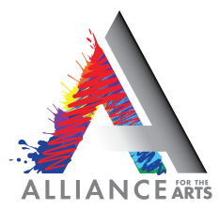

Summer Camp 2023
Hold Harmless Policy

HOLD HARMLESS RELEASE FORM – CAMPER TRAVEL INCLUDED

My signature below states the following:
- I give my child(ren) permission to participate fully in the Alliance for the Arts Summer Camp. I recognize this program includes, but is not limited to, certain physical activities, which may pose some risk of injury. I further understand and agree that the Alliance for the Arts is not an insurer nor is responsible for any costs incurred by me or my child arising from activities conducted within the scope of this program.
- I indemnify and hold harmless the Alliance for the Arts, any of its employees and/or agents from all claims from my use of Alliance property or participation in any programs. I will further indemnify and hold harmless the Alliance, its employees and/or agents from all costs, expenses and liabilities resulting from any claim brought from my child(ren)’s use of Alliance property and/or participation in Alliance programs to the extent of the Alliance’s liability under general law.
- I understand that photographs may be taken of my child during the course of this camp and I give the Alliance for the Arts permission to use these photographs for publicity purposes.
- I have read and fully understand the above important information, warning of risk, and assumption of risk and waiver and release of all claims. If registering via phone, my completed registration shall be substitute for and have the same legal effect as an original form signature.

____________________________________________ _____________________
Signature Date

