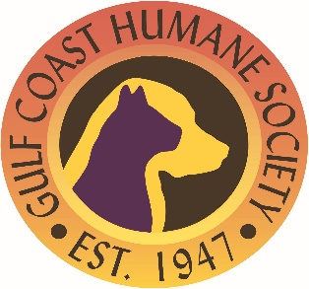

Gulf Coast Humane Society – CALL FOR ENTRIES
Arts & Animals Juried Exhibit: Furry Friends Displayed in Art
Exhibiting Thursday, Sept. 23 at Alliance for the Arts, 6-8 p.m.

To help celebrate the evening of animals and the arts, what better way than intersecting the two in the form of art? “Furry Friends Displayed in Art” is a Juried Exhibit featuring the love of pets. These works can come in any range of medium, except for craft pieces. The pieces should reflect a love for a pet.
The first phase includes submitting pieces digitally, which will be judged and the top submittals moving onto the final stage. The final stage artists will need to deliver their pieces to the Alliance for the Arts framed and ready to be displayed.
ENTRY RULES
This is open to the public and there is no charge to enter your pieces! The artists who are chosen as final stage entrants, will earn a complimentary ticket to that night’s event, which will be held from 6-8 p.m. at the Alliance for the Arts, Thursday, Sept. 23. There will be three winners, all whose pieces will be on display inside the GCHS Adoption Center for a month.
Rules include:
- One entry per artist
- All mediums welcome (no crafts, please)
- The final stage artwork must be framed and ready to display
- Artists are responsible for all delivery or shipping costs
SALES
All submitted works must be offered for sale to the public at a labeled price set by the artists. Entries not for sale will be rejected. A 40-percent donation will be made to help the GCHS shelter animals from the sale of the piece.
LIABILITY
Every effort will be made to handle with care, including protection from loss. Neither the Alliance for the Arts nor Gulf Coast Humane Society will not be liable for loss or damage caused or occurring while work is in exhibition or during shipping. Submission of artwork constitutes an agreement to all conditions of this entry form, including schedule and permission to photograph for publicity purposes.
IMPORTANT DATES
First Phase Digital Submission Deadline: Monday, Sept. 6, at 5 p.m.
Second Phase art drop-off to Alliance for the Arts: Tuesday, Sept. 21, 9-4 p.m.
Arts & Paws Reception: Thursday, Sept. 23, 6-8 p.m. at Alliance for the Arts
Art Pick-Up Deadline: Monday, 27, 4 p.m. – artwork must be picked up at this date/time, no exceptions.

Digital submissions can be made by going to www.ArtInLee.org.

